Ali Tariq
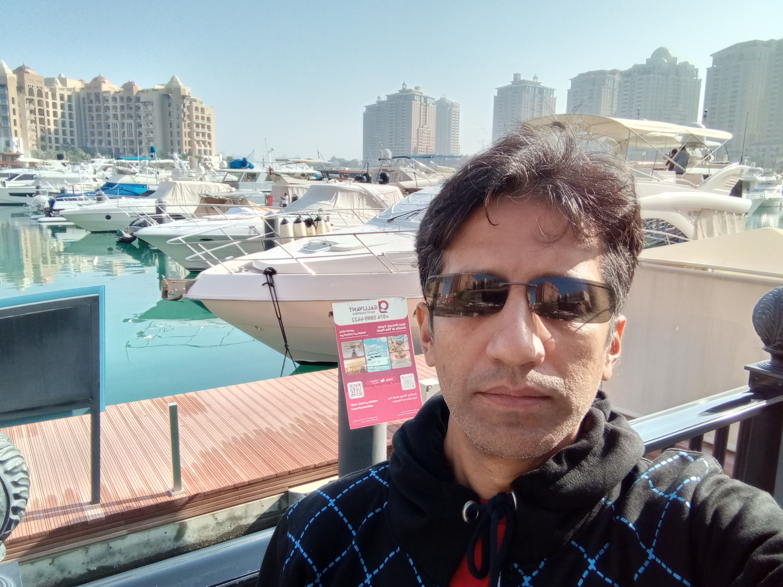
7 years of proven experience in software development

+92 300 1118174 (Pakistan)
+974 51726258 (Qatar)
alibaba420pk@yahoo.com
https://alitariq.cv/resume

SUMMARY

I’m a multidisciplinary software engineer with a background in programming and software development. I have mix of experience in programming languages but most of my past experience is in Java. Currently, I am working as freelancer on a .NET application for my Qatar client and looking for a full-time remote job, also available for relocation in one of Gulf countries.

Skills

Software development & Programming skills:
- Java
- Spring
- Hibernate
- Android
- Kotlin
- C#
- .NET core
- ASP.NET Web APIs
- JavaScript
- Angular JS
- Reactjs
- TypeScript
- Flutter
- Dart
- SQL Server
- Oracle
- MySQL
- PostgreSQL
- NoSQL
- Mongodb
- Firestore
- Microsoft Visual Studio
- VSCode
- Eclipse
- IntelliJ idea
- Android studio
- Xcode
- Apache httpd
- Tomcat
- Jetty
- Nginx
- Microsoft IIS
- Nodejs built-in server
- Cloud Services
- AWS
- GCP
- Microsoft Azure
- Cloudflare
- Alibaba cloud
Operating Systems & System Administrator skills:
- Windows
- Linux
- MacOS
- Android
- iOS
- Microsoft office
- Bash
- Powershell scripting
- 60+ WPM typing speed (test taken on 4/4/2026)
s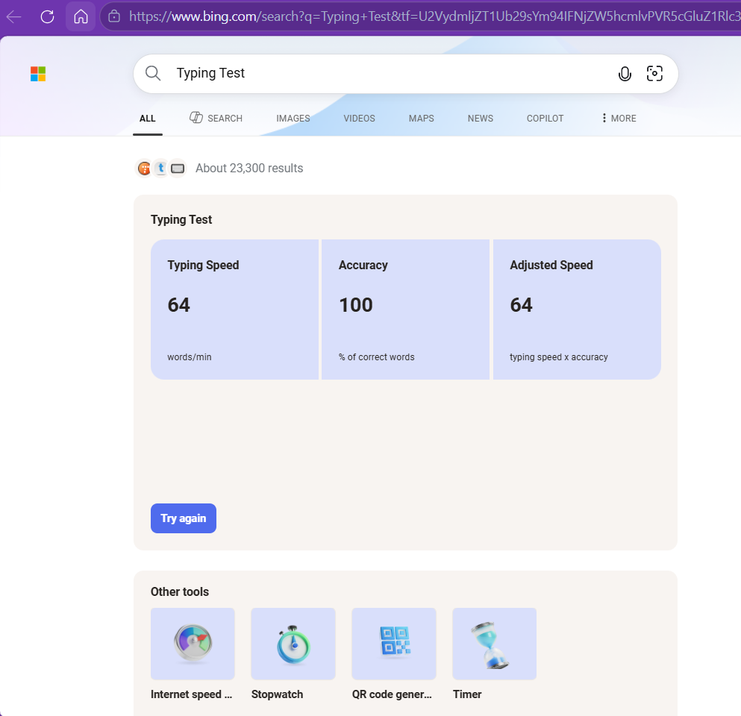
Networking skills:
- LAN
- WAN
- Router settings
- Cisco packet tracer
- LAN wiring setup
Designing skills:
- UI/UX design
- Color Theory
- Adobe illustrator
- Adobe Photoshop
- Corel draw
- Adobe Premier Pro
- Adobe After Effects
- Figma
- Youtube studio
Digital Marketing & SEO skills:
- Google Analytics
- Google Trends
- Google Search Console
- Meta Tags Scheme
- Backlinking

Certified freelancer
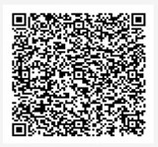

Experience

Freelancer (03/2024 – Now)

CloudCard inc (04/2023 – 02/2024)
Senior Software Engineer
Contact: Head of engineering and product – Adnan Baig adnan.baig@cloudcardinc.com
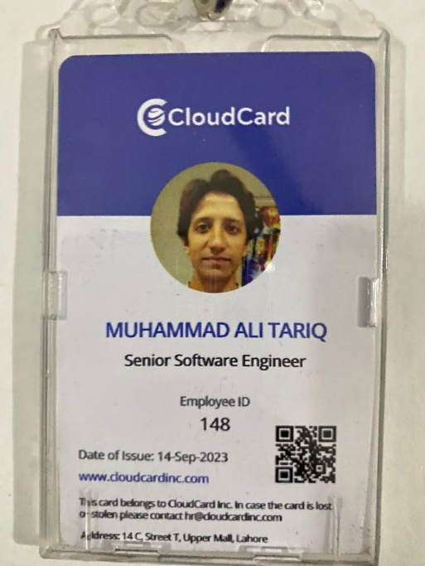
Epazz inc (11/2021 – 03/2023)
Software Engineer
Contact: Mr. Amir – Manager operations aamir@epazz.net
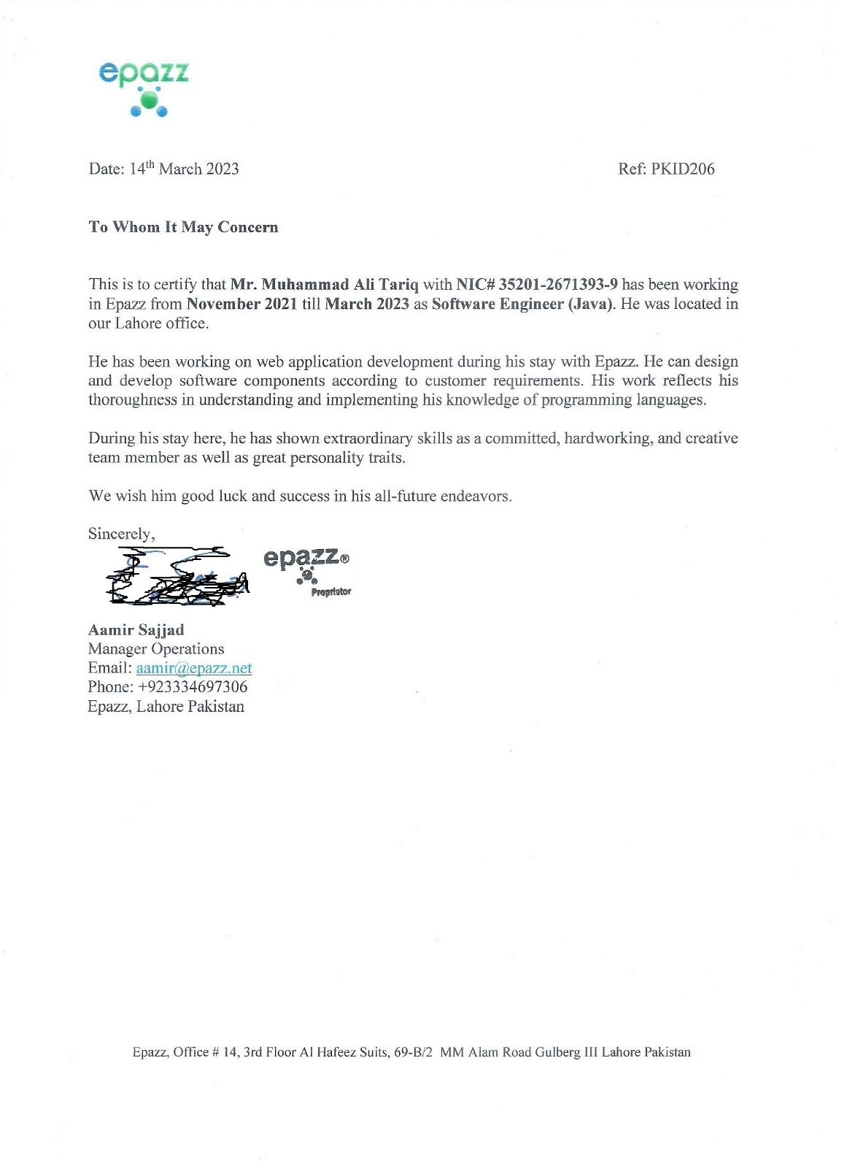

Softech-Systems (04/2021 – 09/2021)
Software Engineer
Contact: Dr. Khushro Shahookar C.T.O khushro@softech.com.pk
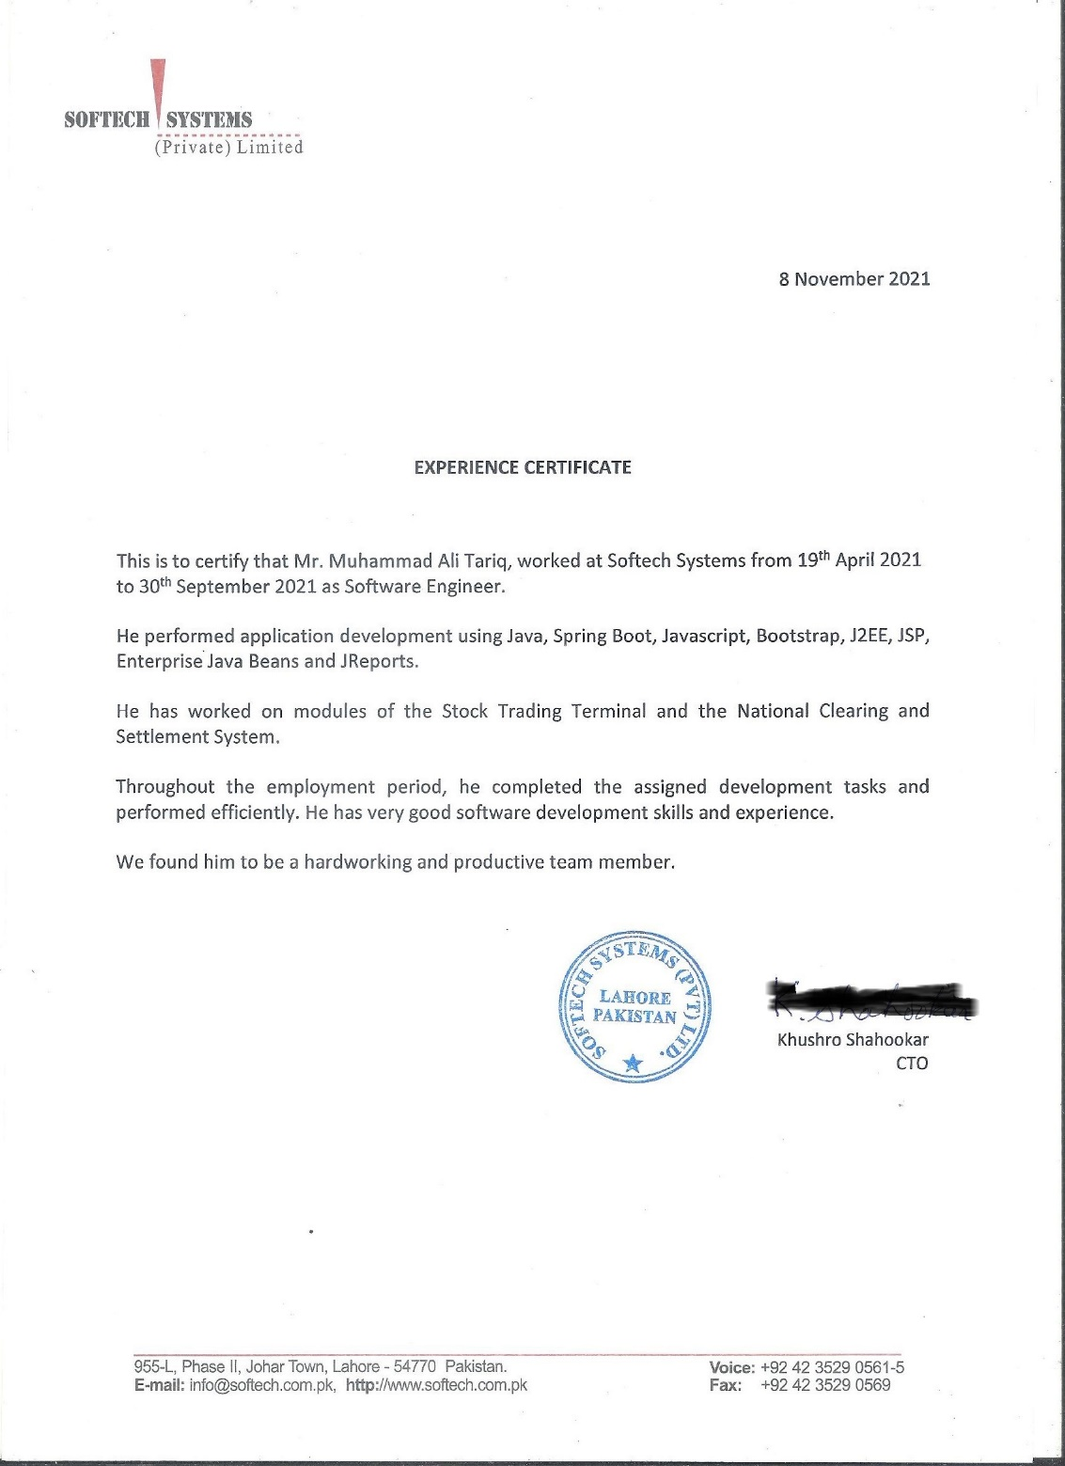

ABS (2019-2021)
Associate Software Engineer
Contact: C.O.O Ahsan Saleem ravian.ahsan@gmail.com

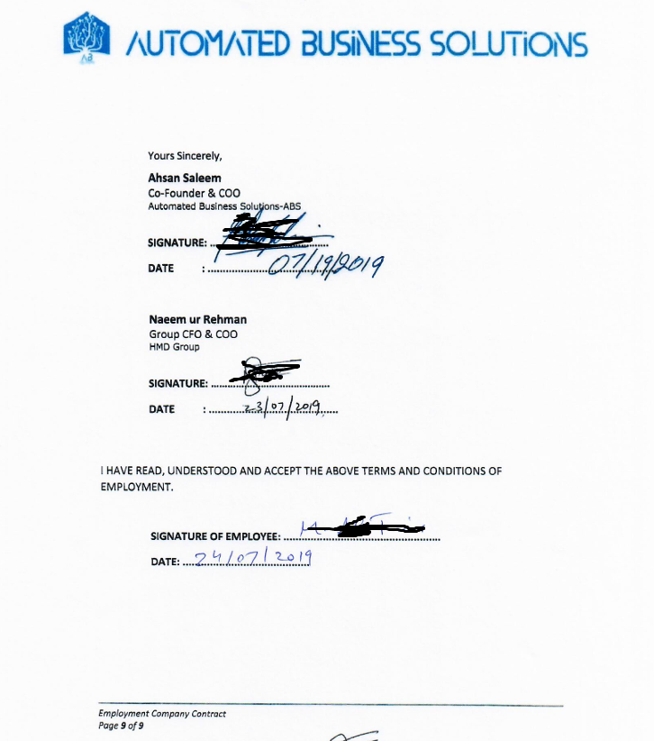

Education

M.Sc. CS (16 years of education equivalent with a bachelor's degree in the US) wiki
Master of Science Computer Science PUCIT (2017-2019)

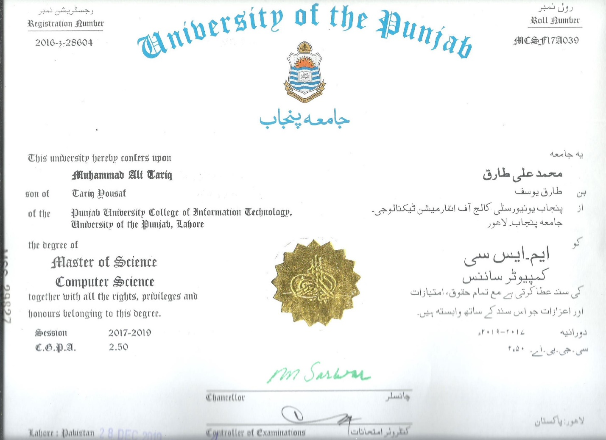

Bachelors of Arts with Mathematics
University of the Punjab (2014-2016)
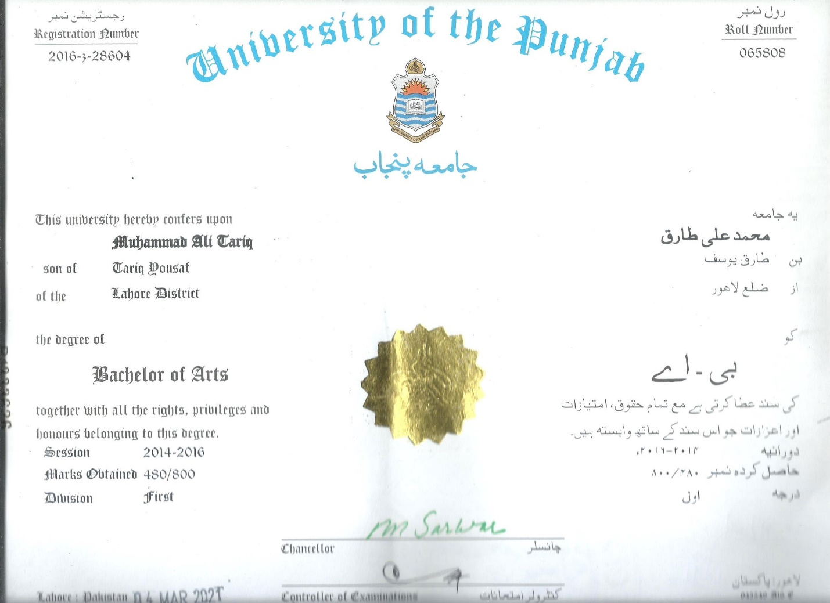
Languages

Urdu: Native
Arabic: Conversational
English: Professional
Chinese: Novice

International travel
Saudi Arabia
Bahrain
Qatar

